Docker Final Challenge

Goal of the Exercise
The goal of this exercise is to test your understanding of a Cloud Compute deployment with Terraform.
You are tasked with creating a codebase for a microservice deployment on a cloud environment, using Terraform. Since our focus is not the application itself, the service will be a simple web server that returns a static page.
Requirements
Service Details
The service will be a simple web server that returns a static page.
You can use apache2 or nginx to serve a simple HTML file.
The service should be containerized and stored in a Docker registry.
The service should be deployed on a single VM instance as a docker container.
The image should be pulled from the registry specified earlier.
- The service should not be accessible from the internet but only through a Load Balancer, except for SSH access from specific IP addresses.
Deliverables
You are to provide the following as part of your solution:
- Dockerfile to build the image.
- Terraform codebase to deploy the following:
- Docker registry
- VPC and all required networking resources
- EC2 instance
- Load Balancer
Notes
Since a CI/CD pipeline is not part of this exercise, we will work around that with the help of Terraform.
To push the image to the Docker registry, build the image locally before running the Terraform code.
Once the image registry is created, use Terraform to push the local image to the registry.
Similarly, use Terraform to pull the image from the registry and run it on the VM instance once it is created.
For SSH access:
Use a locally created key.
Add it to the cloud provider key storage.
Attach it to the instance.
Use Terraform best practices for file structure and code organization.
Use variables, locals, modules, etc. when appropriate.
Include all tfvars, scripts, and other helper files used to deploy the application.
You may use any cloud provider of your choosing, although AWS is preferred.
- Use a free tier account or a trial account to deploy the resources.

Task Title
Deploy a Dockerized NGINX Application on AWS EC2 (Private Subnet) Behind an Application Load Balancer Using Terraform
Objective
To:
- Create a simple NGINX-based Docker application
- Push the Docker image to Docker Hub
- Provision AWS infrastructure using Terraform
- Deploy an EC2 instance in a private subnet
- Expose the application publicly via an Application Load Balancer (ALB)
Prerequisites
- Docker Desktop installed and running
- Docker Hub account (krishnav7090)
- AWS account with access keys configured
- Existing EC2 key pair (NV.pem)
- Terraform installed
- Visual Studio Code
- AWS region: us-east-1 (N. Virginia)

Step-by-Step Implementation:

PART 1: Docker Application
Step 1: Create Application Files
Location: microservice-simple/docker/
- index.html
<!DOCTYPE html>
<html>
<body>
<h1>Terraform Docker App</h1>
<p>Private app behind Load Balancer</p>
</body>
</html>
- Dockerfile
FROM nginx:alpine
COPY index.html /usr/share/nginx/html/index.html
EXPOSE 80
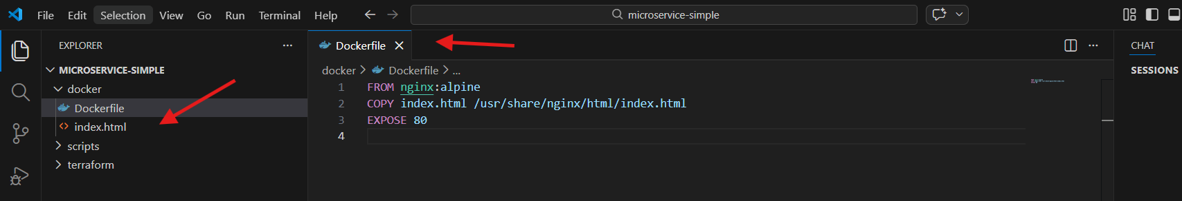
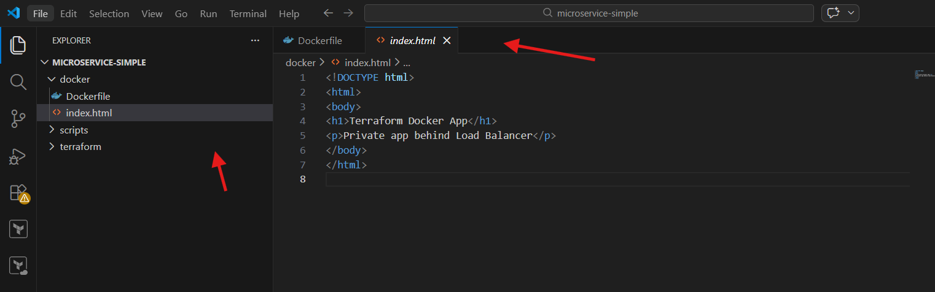
Step 2: Build Docker Image
Executed in: VS Code Terminal
Directory: microservice-simple/docker
docker build -t krishnav7090/microservice:latest .
Image successfully built
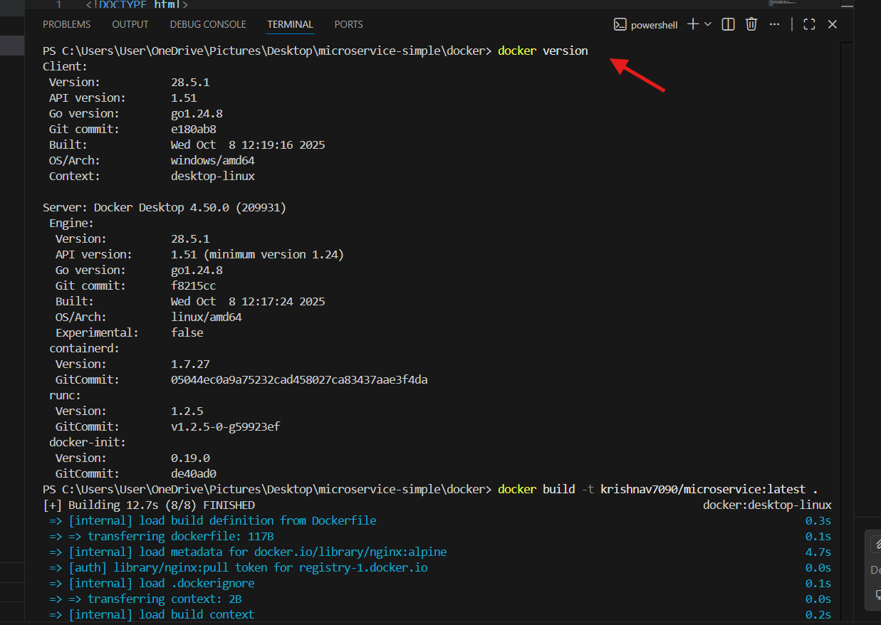
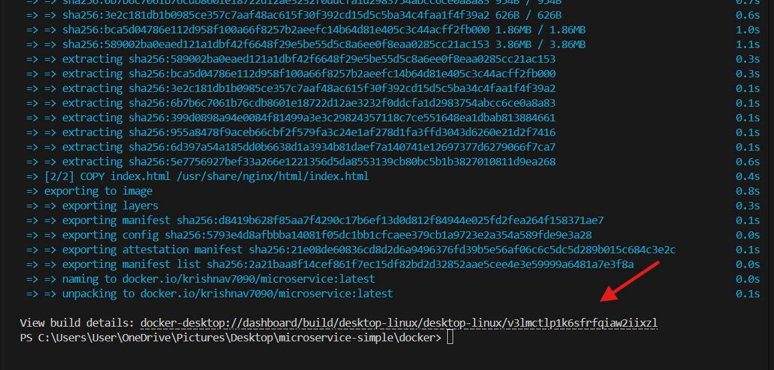
Verified using:
docker images
Step 3: Test Docker Image Locally
docker run -d -p 8080:80 krishnav7090/microservice:latest
- Page loaded successfully
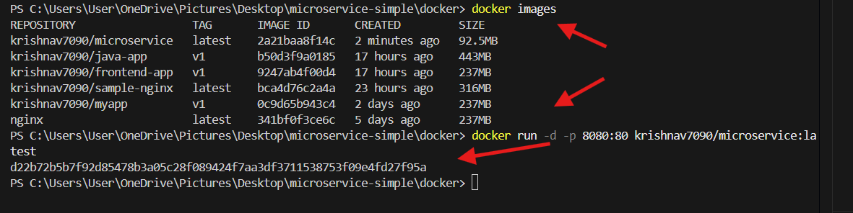
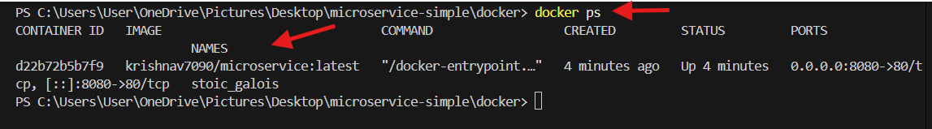
- Accessed in browser:
http://localhost:8080
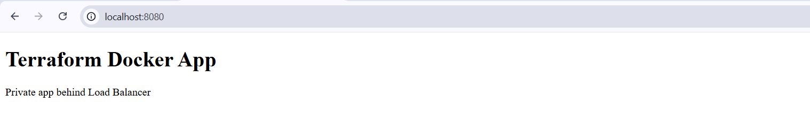
Step 4: Push Image to Docker Hub
docker push krishnav7090/microservice:latest
- Image visible in Docker Hub
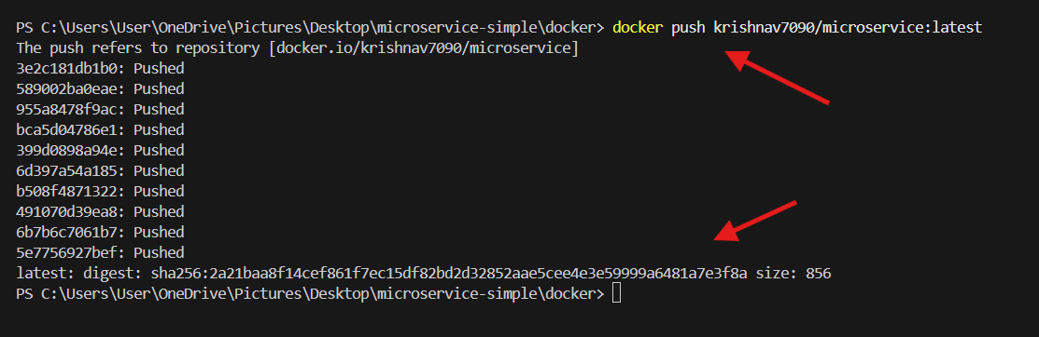
- Repository: krishnav7090/microservice

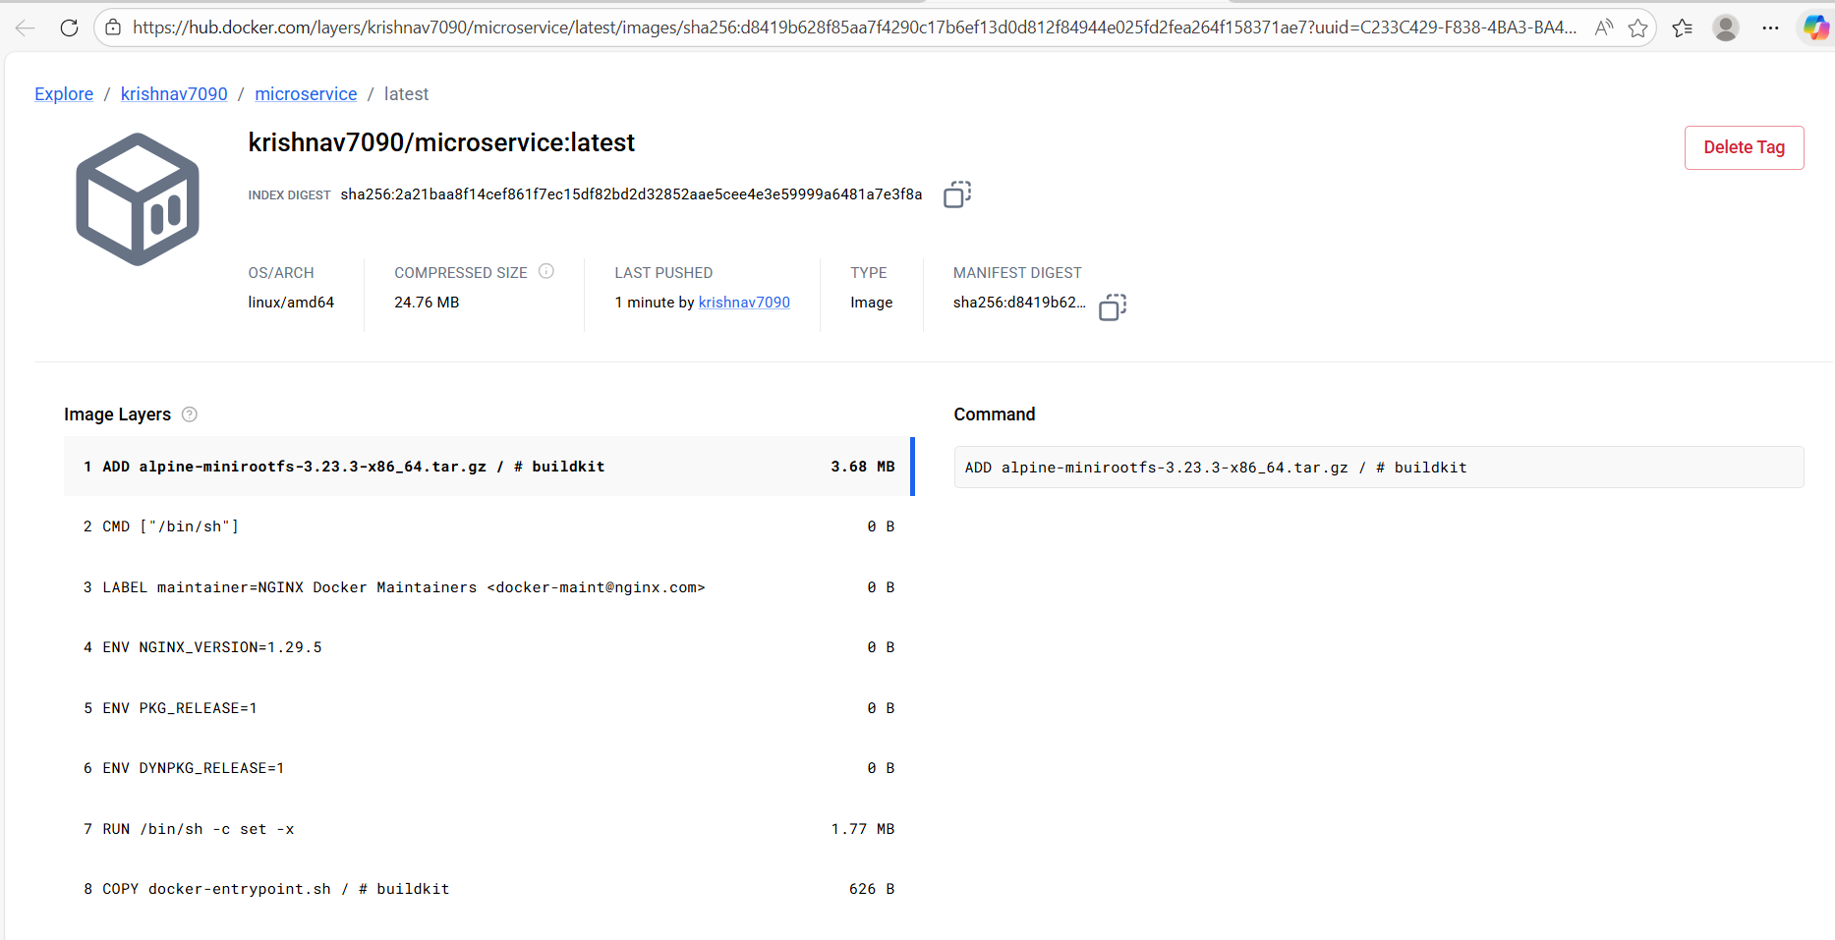

PART 2: Infrastructure Provisioning with Terraform

Step 5: Terraform Project Structure
Location: microservice-simple/terraform/
terraform/
│── main.tf
│── provider.tf
│── variables.tf
│── terraform.tfvars
│── output.tf
│── terraform.tfstate

Step 6: Configure AWS Provider
provider.tf
provider "aws" {
region = "us-east-1"
}
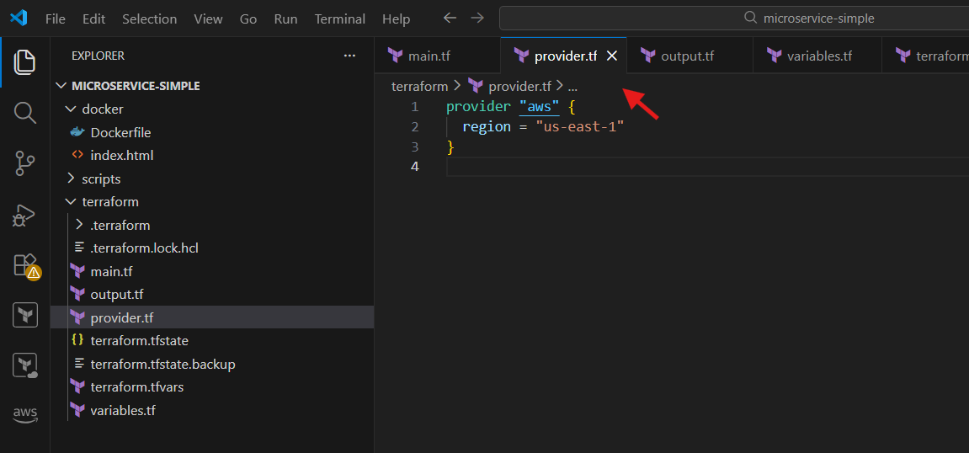
Output.tf:
output "alb_dns_name" {
description = "Public DNS name of the Application Load Balancer"
value = aws_lb.alb.dns_name
}
output "ec2_private_ip" {
description = "Private IP address of the EC2 instance"
value = aws_instance.ec2.private_ip
}
output "vpc_id" {
description = "VPC ID"
value = aws_vpc.main.id
}
output "alb_security_group_id" {
description = "Security Group ID of ALB"
value = aws_security_group.alb_sg.id
}
output "ec2_security_group_id" {
description = "Security Group ID of EC2"
value = aws_security_group.ec2_sg.id
}
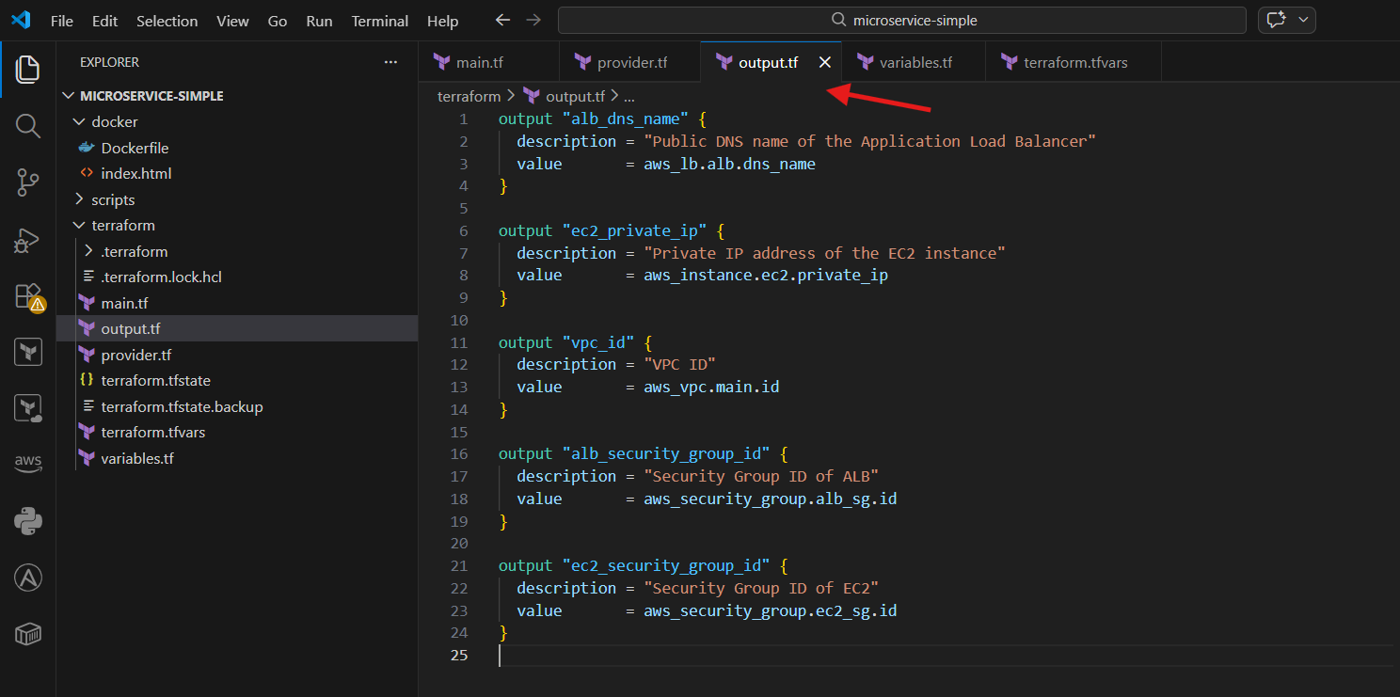
Step 7: Define Variables
variables.tf
variable "docker_image" {}
variable "allowed_ssh_ip" {}
variable "key_name" {}
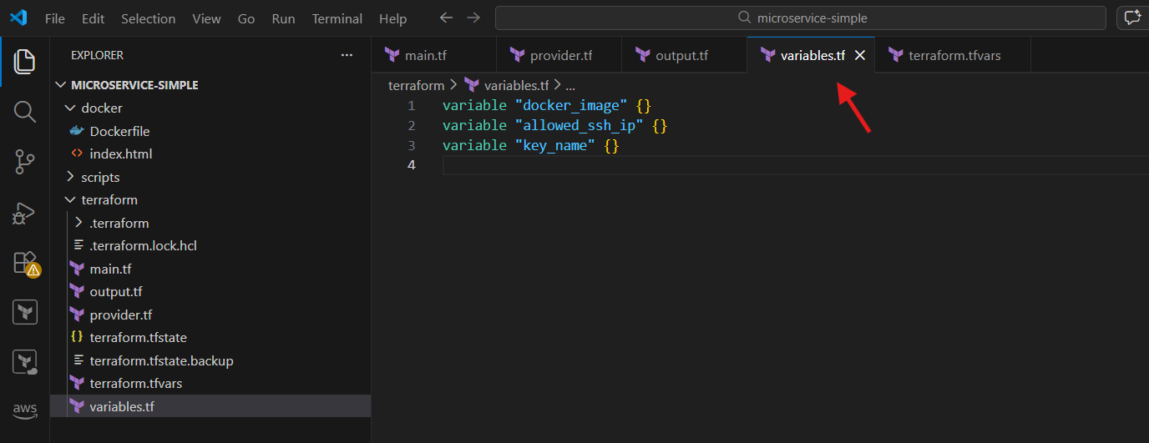
terraform.tfvars
docker_image = "krishnav7090/microservice:latest"
allowed_ssh_ip = "14.192.14.53/32"
key_name = "NV"
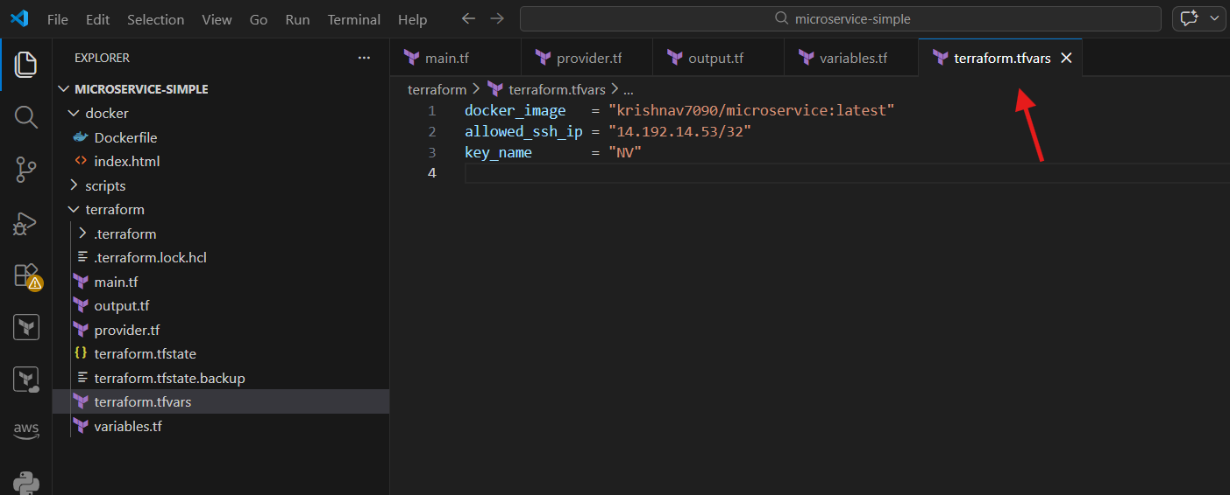
Step 8: Infrastructure in main.tf
Resources created using Terraform:
- VPC
- Internet Gateway
- Public Route Table
- Two Public Subnets (different AZs)
- One Private Subnet
- ALB Security Group
- EC2 Security Group
- Application Load Balancer
- Target Group
- Listener
- EC2 Instance (private subnet)
- Target Group Attachment

Main.tf:
# Availability Zones
data "aws_availability_zones" "available" {}

# VPC
resource "aws_vpc" "main" {
cidr_block = "10.0.0.0/16"
}

# Internet Gateway
resource "aws_internet_gateway" "igw" {
vpc_id = aws_vpc.main.id
}

# Public Route Table
resource "aws_route_table" "public_rt" {
vpc_id = aws_vpc.main.id

route {
cidr_block = "0.0.0.0/0"
gateway_id = aws_internet_gateway.igw.id
}
}

# Public Subnets (2 AZs)
resource "aws_subnet" "public_1" {
vpc_id = aws_vpc.main.id
cidr_block = "10.0.1.0/24"
availability_zone = data.aws_availability_zones.available.names[0]
map_public_ip_on_launch = true
}

resource "aws_subnet" "public_2" {
vpc_id = aws_vpc.main.id
cidr_block = "10.0.2.0/24"
availability_zone = data.aws_availability_zones.available.names[1]
map_public_ip_on_launch = true
}

# Route Table Associations
resource "aws_route_table_association" "public_1_assoc" {
subnet_id = aws_subnet.public_1.id
route_table_id = aws_route_table.public_rt.id
}

resource "aws_route_table_association" "public_2_assoc" {
subnet_id = aws_subnet.public_2.id
route_table_id = aws_route_table.public_rt.id
}
# Private Subnet (EC2)
resource "aws_subnet" "private" {
vpc_id = aws_vpc.main.id
cidr_block = "10.0.3.0/24"
availability_zone = data.aws_availability_zones.available.names[0]
}

# ALB Security Group
resource "aws_security_group" "alb_sg" {
name = "alb-sg"
vpc_id = aws_vpc.main.id

ingress {
from_port = 80
to_port = 80
protocol = "tcp"
cidr_blocks = ["0.0.0.0/0"]
}

egress {
from_port = 0
to_port = 0
protocol = "-1"
cidr_blocks = ["0.0.0.0/0"]
}
}
# EC2 Security Group
resource "aws_security_group" "ec2_sg" {
name = "ec2-sg"
vpc_id = aws_vpc.main.id

ingress {
from_port = 22
to_port = 22
protocol = "tcp"
cidr_blocks = [var.allowed_ssh_ip]
}

ingress {
from_port = 80
to_port = 80
protocol = "tcp"
security_groups = [aws_security_group.alb_sg.id]
}

egress {
from_port = 0
to_port = 0
protocol = "-1"
cidr_blocks = ["0.0.0.0/0"]
}
}
# Application Load Balancer
resource "aws_lb" "alb" {
name = "tf-alb"
load_balancer_type = "application"
security_groups = [aws_security_group.alb_sg.id]

subnets = [
aws_subnet.public_1.id,
aws_subnet.public_2.id
]
}
# Target Group
resource "aws_lb_target_group" "tg" {
port = 80
protocol = "HTTP"
vpc_id = aws_vpc.main.id

health_check {
path = "/"
matcher = "200"
}
}

# Listener
resource "aws_lb_listener" "listener" {
load_balancer_arn = aws_lb.alb.arn
port = 80
protocol = "HTTP"

default_action {
type = "forward"
target_group_arn = aws_lb_target_group.tg.arn
}
}
# EC2 Instance (Docker runs here)
resource "aws_instance" "ec2" {
ami = "ami-02777684819ca2214"
instance_type = "m7i-flex.large"
subnet_id = aws_subnet.public_1.id
vpc_security_group_ids = [aws_security_group.ec2_sg.id]
key_name = var.key_name

user_data = <<EOF
#!/bin/bash
dnf update -y
dnf install -y docker
systemctl enable docker
systemctl start docker
docker pull ${var.docker_image}
docker run -d -p 80:80 ${var.docker_image}
EOF
}
# Attach EC2 to Target Group
resource "aws_lb_target_group_attachment" "ec2_attach" {
target_group_arn = aws_lb_target_group.tg.arn
target_id = aws_instance.ec2.id
port = 80
}
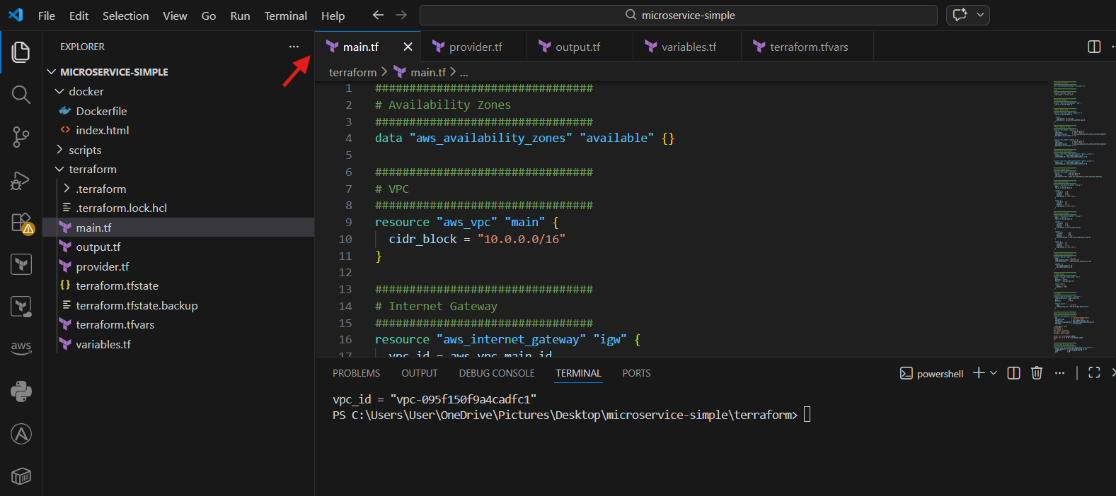
Step 9: Initialize Terraform
terraform init
- Provider initialized successfully
Step 10: Apply Terraform Configuration
terraform apply
- Confirmed with yes
- 15 resources created
- No errors
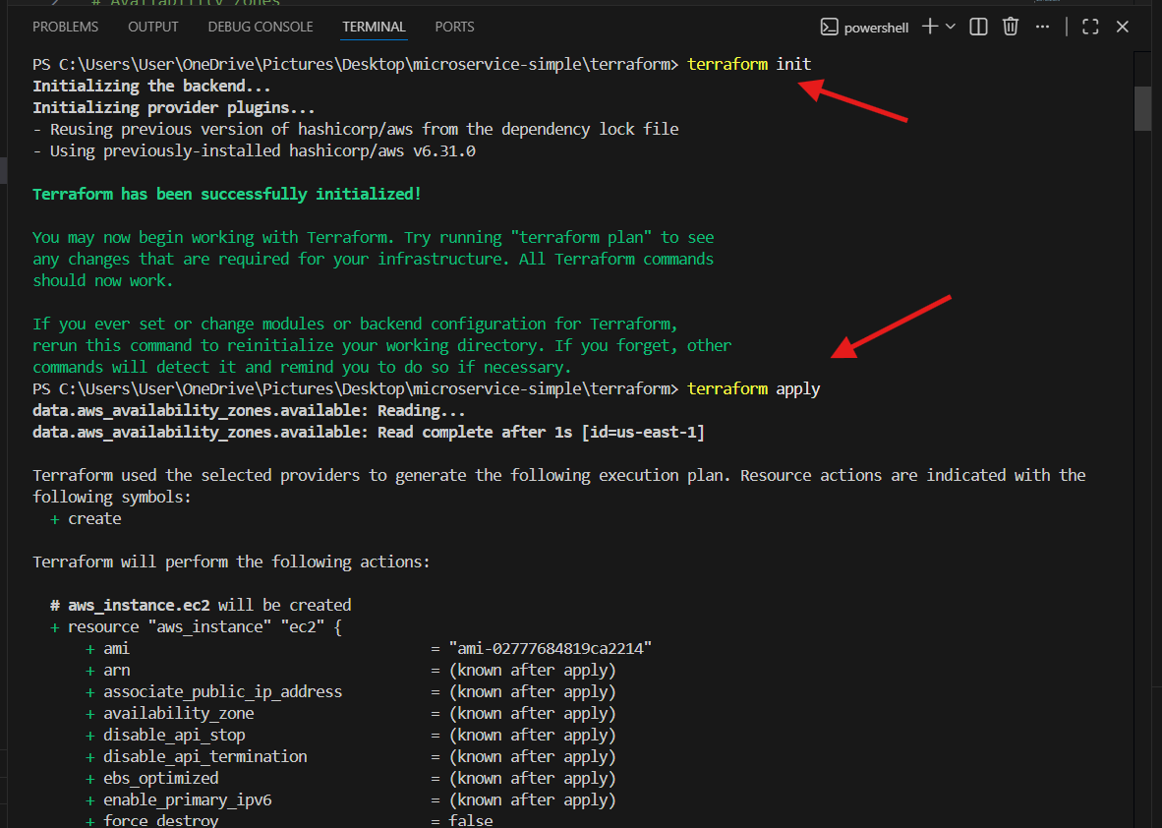
Step 11: Verify Outputs
output.tf
output "alb_dns_name" {
value = aws_lb.alb.dns_name
}
output "ec2_private_ip" {
value = aws_instance.ec2.private_ip
}
output "vpc_id" {
value = aws_vpc.main.id
}
Terraform displayed:
- ALB DNS name
- EC2 private IP
- Security group IDs
- VPC ID
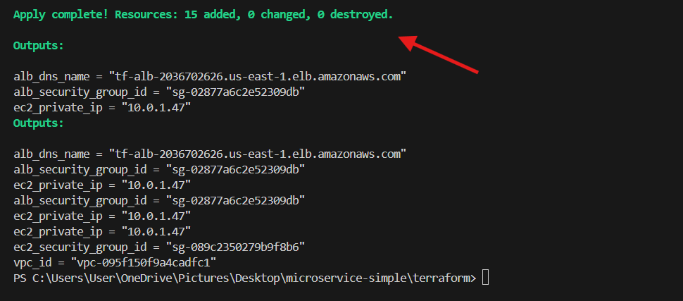
Validation Steps
1. Docker Validation
- Local container ran successfully
- Browser displayed HTML page
- Image pushed to Docker Hub
2. AWS Validation
- ALB status: Active
- Target group: Healthy
- EC2 instance: Running
- Security groups correctly configured
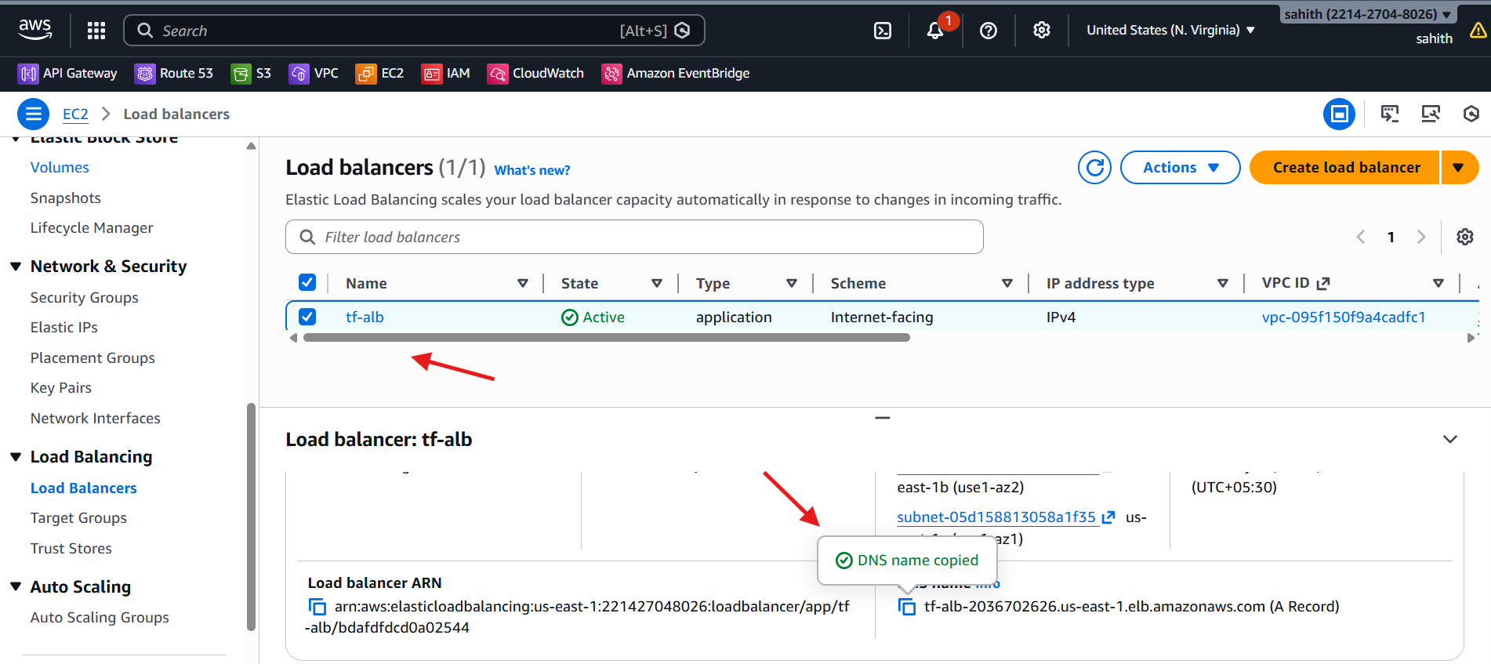
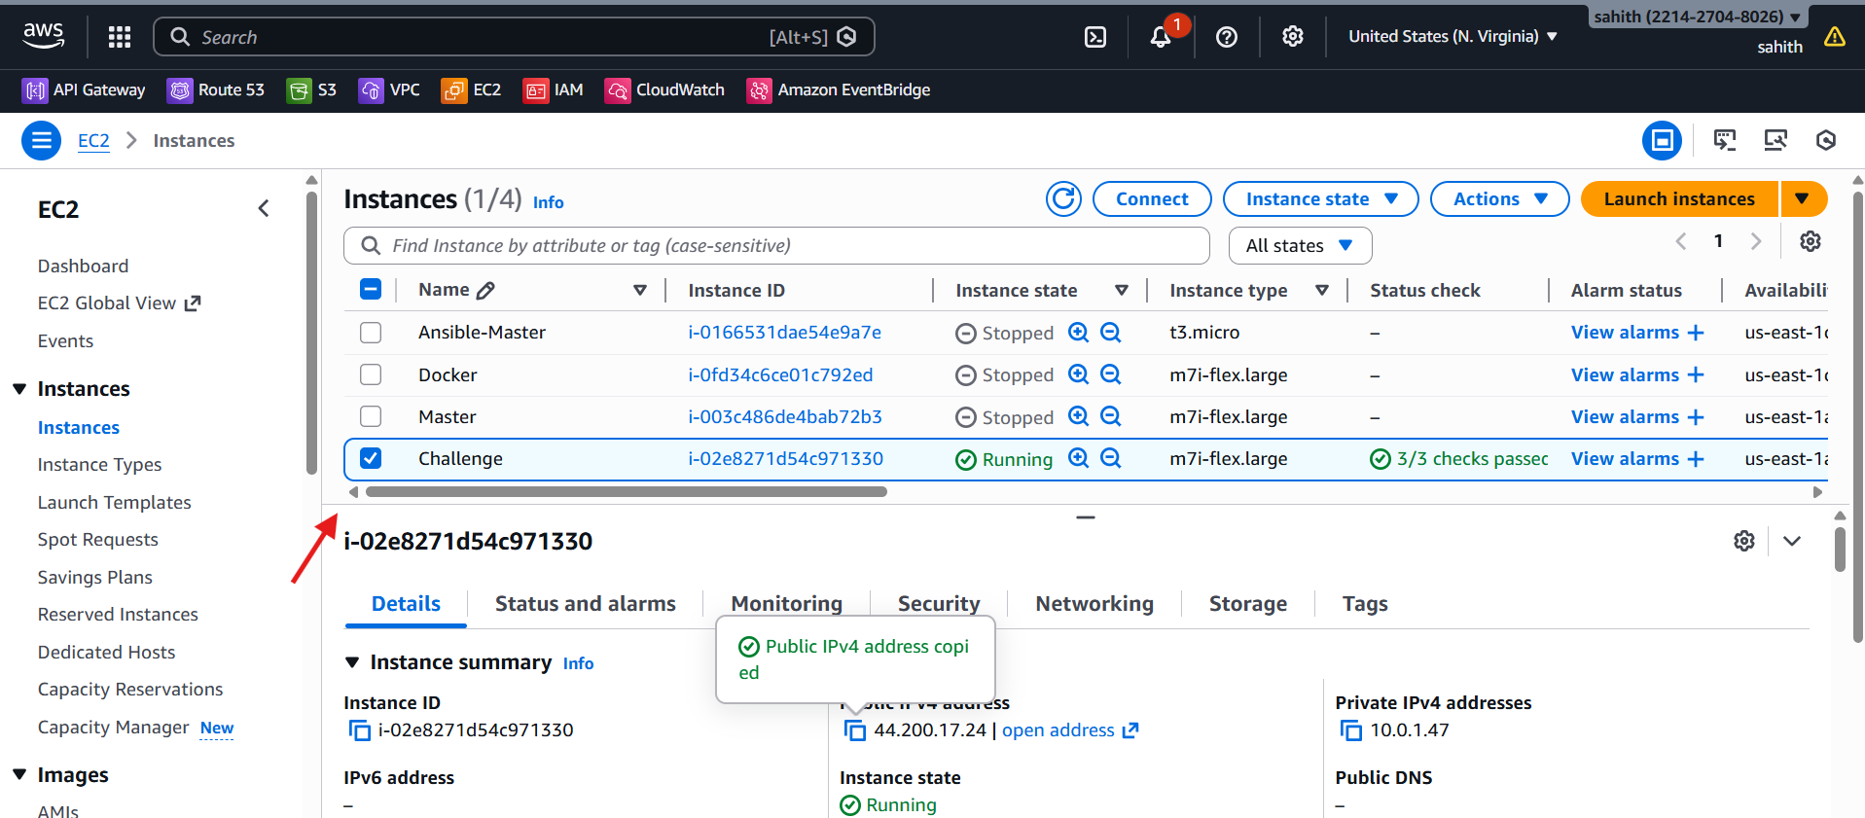
3. Application Validation
- Accessed ALB DNS in browser:
http://tf-alb-xxxxx.us-east-1.elb.amazonaws.com
- Page loaded successfully:
Terraform Docker App
Private app behind Load Balancer

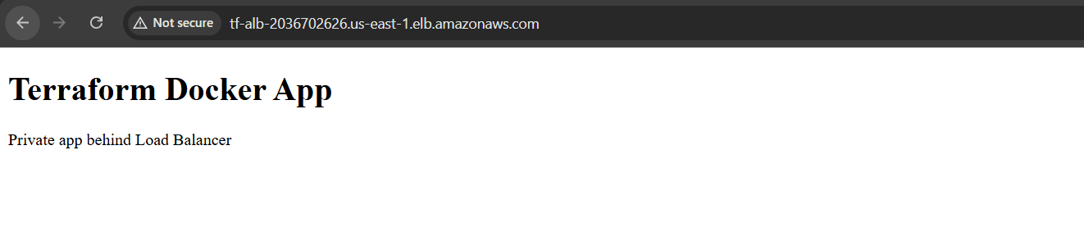

Issues Faced & Resolutions
Issue | Resolution
502 Bad Gateway | Added correct health check and fixed EC2 SG
Target group unhealthy | Ensured Docker runs on port 80
ALB creation failed | Added 2 public subnets in different AZs
No internet access | Added Internet Gateway + route table
AMI not found | Used correct us-east-1 AMI
SSH CIDR error | Replaced placeholder with actual IP

Conclusion
Successfully:
- Built and tested a Dockerized NGINX app
- Published the image to Docker Hub
- Provisioned AWS infrastructure using Terraform
- Deployed EC2 in a private subnet
- Exposed application securely via ALB
- Validated end-to-end access using ALB DNS
This setup demonstrates real-world DevOps skills including Docker, AWS networking, Terraform IaC, and load-balanced application deployment.

